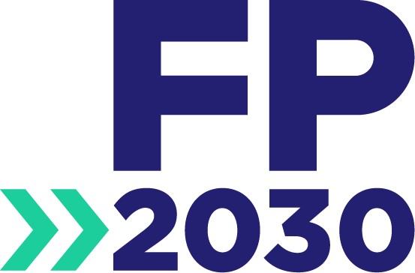
FP2030 Commitment Social Media Toolkit

Thank you for joining the FP2030 partnership by making a commitment to family planning services for women and girls. We are excited to see your commitment! The FP2030 partnership strives for a future where all women and girls have the freedom and ability to lead healthy lives, make their own informed decisions about using contraception and having children, and participate as equals in society and its development.
This social media toolkit is a collection of social media messages and other assets to announce your commitment to your own citizens. We hope you will share your excitement over the new commitment—the FP2030 Support Network will amplify this announcement on our own platforms— and encourage other country governments to make commitments. In addition, you can also use messages to highlight the importance of rights-based commitments, the strength of the family planning community, and the impact of COVID-19. Be sure to tag FP2030 @FP2030Global on Twitter, Facebook, and Instagram when sharing these messages on social media so we can repost your content.
For more information on the FP2030 commitments process, guidance, or any frequently asked questions, please visit commitments.fp2030.org.

Hashtags
#FP2030
#FP2030Partnership
#FP2030Commitments
#RoadToFP2030

Pictures/GIFs
Use pictures and GIFs from this folder when posting on Twitter, Facebook, and Instagram https://bit.ly/3v22u3j

Sample Messages

CELEBRATE YOUR COMMITMENT
We are excited to be a part of the #FP2030Partnership! 🎉Our commitment will continue to expand #familyplanning for women and girls in [Country name]. #FP2030Commitments
📣 [Country name] is part of the #FP2030Partnership! Our FP2030 commitment includes a stronger role for civil society—including equitable partnerships with adolescents and youth—and a framework for mutual accountability from the start.
We are a part of the global #FP2030Partnership 🌍 [Country name] will continue to uphold the right of women and girls to lead healthy lives and to make their own informed decisions about using #contraception. #FP2030Commitments
Our commitment to the #FP2030Partnership will help to ensure women and girls have the freedom and ability to lead healthy lives, make their own informed decisions about using #contraception and having children, and participate as equals in society and its development.
We are excited to be a part of the #FP2030Partnership with other members of governments, civil society, multilateral organizations, donors, the private sector, researchers, and the humanitarian and development community working together.

ENCOURAGE OTHERS TO MAKE A COMMITMENT
📣 We’ve joined the #FP2030Partnership to continue advancing #familyplanning around the world! Join the #FP2030Partnership and make a commitment today! #RoadToFP2030
#DYK [country name] has joined the #FP2030Partnership? We are investing in the women and girls of this country, in their health and economic security, in their futures — and the future of our nation. Join @FP2030Global and make a commitment today!
📢 We’ve made a commitment to @FP2030Global to expand #familyplanning to women and girls everywhere, centered in human rights, in a spirit of self-examination and growth. Join us and make a commitment! #RoadToFP2030
We just joined the global #FP2030Partnership 🌍 [Country name] is ready to foster a deeper partnership with civil society, including youth groups. Are you? Join @FP2030Global and make a commitment! #RoadToFP2030

HIGHLIGHT RIGHTS-BASED COMMITMENTS
We are a part of the #FP2030Partnership! [Country name] is committed to providing quality #familyplanning services for all regardless of socioeconomic or marital status, gender identity or sexual orientation.
Why are we a part of the #FP2030Partnership? [Country name] believes each person has the same right to quality #familyplanning information, products, and services, regardless of their age, ethnicity, race, sexuality disability, or culture.
We are proud to be a part of the global #FP2030Partnership 🌍[Country name] continually works to improve system responsiveness to individual rights and needs and improve the policy agenda around family planning.
#DYK we are a part of the #FP2030Partnership? [Country name] is committed to advance rightsbased principles, with a focus on high-impact, evidence-based practices that deliver the best health and societal outcomes.
📣 [Country name] has joined the #FP2030Partnership! Our #FP2030 commitment includes recognizing the importance of transforming social and gender norms in order to create an environment that supports women and girls who decide to use #familyplanning.

HIGHLIGHT RIGHTS-BASED COMMITMENTS
📣 We made a commitment to our citizens to join the #FP2030Partnership! As part of this partnership, we will help accelerate global progress on Universal Health Coverage and the Sustainable Development Goals. #UHC #SDGs
[Country name] is proud to be a part of the #FP2030Partnership! We will work to continue advancing #familyplanning and the ICPD Programme of Action’s promise of universal access to #SRH around the world. #ICPD25
Commit to the #FP2030Partnership ✅ [Country name] is committed to collectively transforming the lives of women, girls, and communities for generations to come. #everywoman
📣 We made a commitment to our citizens to join the #FP2030Partnership! As part of this partnership, we will help accelerate progress towards gender equality. #GenerationEquality
Now more than ever, [country name] is committed to the #FP2030Partnership! We will help advance the goals set out by @PMNCH #LivesInTheBalance Summit on #COVID19 by committing to improve investments in health systems for women and girls.

HIGHLIGHT THE IMPACT OF COVID-19
In the midst of the #COVID19 pandemic, [Country name] recognizes it will have a catastrophic impact on #familyplanning services. This is why we’re committed to the global #FP2030Partnership.
[Country name] has joined the #FP2030Partnership ✅ That’s the first step to mitigate the catastrophic impact of the #COVID19 pandemic on #familyplanning services @FP2030Global
#DYK COVID-19 has the potential to be the biggest setback to gender equality in a generation. This is why [Country name] has made a commitment to ensure women and girls everywhere have access to contraception.
📣 [Country name] has joined the #FP2030Partnership! With traditionally underserved and overlooked populations at particular risk of losing needed services to #COVID19, we are committed to ensuring that no one is left behind.

